**Internship Evaluation & Reporting**

Thank you for taking the time to complete this form, this evaluation will be used to assess the student’s participation in the internship program.

Supervisors, using the form below please evaluate the student who interned with your organization, institution, or business. You can fill out this form electronically or you can fill it manually but eventually it must be signed and stamped from the company’s side.

Please note that part I & III should be completed by the intern, part II should be completed by the direct supervisor in the company.

**Part I. GENERAL INFORMATION – STUDENT’S INPUT**

**Student Info:**

Student Name: __________________________ GUC Student ID No.:_____________________________

Faculty: ________________________________ Major: ________________________________________

Student Mobile No.:_______________________

**Internship Info:**

Company Name: _______________________________________________________________________

Core Industry/Business: ___________________ Country: ______________________________________

Supervisor Name: ________________________ Supervisor Job Title: _____________________________

Supervisor Tel. No.: ______________________ Supervisor Mobile No.:____________________________

Supervisor E-mail: ________________________ Training Department(s): _________________________

Source of internships: (1) SCAD office (2) on my own (3) Referrals from GUC TA/Dr. (4) Recruitment website (5) others:

Work Place: (1) Organization (2) Head Office (3) Branch (4) Factory (5) Site (6) Others:

-----------------------------------------------------------------------------------------------------------------------

**Part II. EVALUATION AND COMMENTS – DIRECT SUPERVISOR’S INPUT**

Period of Internship **(dd/mm/yyyy)** **(dd/mm/yyyy)**

**From:** ____/____/_________ **To:** ____/____/________

Internship nature (Enrollment Status)

* Part time Please specify, no. of Days per week:___________ hours per day :______________
* Full time Please specify, no. of Days per week:___________ hours per day :_____________

**Company Stamp** 

-----------------------------------------------------------------------------------------------------------------------

**For SCAD internal use only**





Please evaluate student's performance by marking the appropriate box:

For each of the following aspects, please mark the box in the rating scale that most closely corresponds to your evaluation of the profile of the student during the internship period. Please also feel free to offer comments and suggestions for changes and improvements in the space provided at the end of the form.

| **1=Unsatisfactory 2=Below Average 3=Satisfactory 4=Above Average 5=Excellent** |
| --- |

|  | **1** | **2** | **3** | **4** | **5** | **NA** |
| --- | --- | --- | --- | --- | --- | --- |
| **Skills & Professional Attributes** | | | | | | |
| Ability to adapt to change |  |  |  |  |  |  |
| Analytical skills |  |  |  |  |  |  |
| Collecting data/ research data skills |  |  |  |  |  |  |
| Creativity |  |  |  |  |  |  |
| Follow up skills |  |  |  |  |  |  |
| Interpersonal skills with peers, supervisors, and clients |  |  |  |  |  |  |
| Problem solving |  |  |  |  |  |  |
| Punctuality |  |  |  |  |  |  |
| Reporting skills |  |  |  |  |  |  |
| Responsibility and accountability |  |  |  |  |  |  |
| Stress handling |  |  |  |  |  |  |
| Taking initiatives |  |  |  |  |  |  |
| Teamwork |  |  |  |  |  |  |
| Time management |  |  |  |  |  |  |
| Other: |  |  |  |  |  |  |
| **Technical Background** | | | | | | |
| Technical Knowledge |  |  |  |  |  |  |
| Compatibility of technical skills with the job |  |  |  |  |  |  |
| Other: |  |  |  |  |  |  |
| **Command of Languages** |  |  |  |  |  |  |
| Arabic |  |  |  |  |  |  |
| English |  |  |  |  |  |  |
| German |  |  |  |  |  |  |
| Other: |  |  |  |  |  |  |

| **1=Unsatisfactory 2=Below Average 3=Satisfactory 4=Above Average 5=Excellent** |
| --- |

|  | **1** | **2** | **3** | **4** | **5** | **NA** |
| --- | --- | --- | --- | --- | --- | --- |
| **Computer Programs & Databases**  **Please use space below in specifying the program/software used during the internship and evaluate student’s performance accordingly** | | | | | | |
|  |  |  |  |  |  |  |
|  |  |  |  |  |  |  |
|  |  |  |  |  |  |  |
|  |  |  |  |  |  |  |
|  |  |  |  |  |  |  |

| **Overall Evaluation of Student’s performance and profile** | | | | | |
| --- | --- | --- | --- | --- | --- |
| Unsatisfactory | Improvement needed | Meets expectations | Exceeds expectations | Exceptional | NA |
|  |  |  |  |  |  |

**General Comments & Recommendations:** (kindly mention intern potentials, areas of further development or technical constraintsencountered during the internship period)

__________________________________________________________________

__________________________________________________________________

__________________________________________________________________

__________________________________________________________________

__________________________________________________________________

__________________________________________________________________

|  | **Yes** | **No** | **Maybe** |
| --- | --- | --- | --- |
| Do you think similar candidates would fit in the  Organization culture and qualify for job needs? |  |  |  |

**Student Signature: Date:**

______________________________ __________________________

**Supervisor Signature: Date:**

______________________________ __________________________

**Part III. INTERNSHIP REPORT – STUDENT’S INPUT**

* This report has to be prepared by the student, it must be prepared and written in a **computerized** format, submitting the report in hand written format will not be accepted.
* Kindly refer to the Internship Report writing Guidelines on the GUC intranet – SCAD office folder.
* This report will be reviewed and evaluated from internal faculty members.

**Internship Title:** IBM Summer Internship Program 2023

**Company / Organization Name:** IBM

**Introduction:**

In this report, I will share the insights and knowledge gained during my 8-week internship at IBM, where I held the position of Junior Backend Developer. My motivation for joining IBM was to deepen my expertise in backend development and enhance my understanding of large-scale software projects. IBM’s reputation for innovation and its pioneering solutions across multiple industries, including tourism, made it an appealing choice for this opportunity. Throughout the report, I will provide an overview of the company, detail the tasks I was involved in, offer an evaluation of the internship, and conclude with reflections on the experience and its impact on my career.

**Company / Organization Description:**

IBM, a global leader in technology and consulting services, has been at the forefront of innovation for over a century. Known for pioneering advancements in AI, cloud computing, and blockchain, IBM serves a wide range of industries, from healthcare to finance. During my internship, I was part of a team working on the "Cleopatra" project, a tourism platform aimed at providing end-to-end services for travelers. IBM’s dedication to using technology to streamline business processes and enhance customer experiences was evident throughout my time there. The company’s collaborative work culture and global presence provided a rich environment for learning and growth.

**Internship Performed Tasks:**

As part of the backend development team for Cleopatra, a comprehensive tourism app and website, I worked on developing essential features to support tourists throughout their journey. This included building and refining APIs for transportation booking, hotel reservations, flight management, and museum ticketing. My tasks involved writing efficient, scalable code in Node.js, creating RESTful services, and ensuring seamless integration between various modules. I worked extensively with PostgreSQL for storing and managing user information, ensuring optimal database performance. Additionally, I tested APIs using Postman to validate their functionality and collaborated with the frontend team to optimize data retrieval and display. I also documented the APIs using Swagger, enabling the frontend teams to easily access and integrate the services. Throughout the internship, I gained valuable experience in developing complex systems that cater to the needs of an international user base.

**Internship Evaluation:**

This internship helped me develop a wide range of backend development skills, particularly in building scalable systems and API development. It exceeded my expectations by providing hands-on experience with real-world projects and exposing me to the complexities of the tourism industry. I also gained valuable insights into team collaboration and the processes involved in building and maintaining large-scale applications. Additionally, it strengthened my ability to handle work under pressure and improved my time management skills, as I often had to meet tight deadlines while maintaining high-quality results. The experience also expanded my professional network, allowing me to connect with and learn from experienced developers, sharing knowledge and best practices. Overall, this opportunity has boosted my confidence and solidified my interest in backend development.

**Conclusion:** My internship at IBM was an enriching experience that offered me a deep dive into the tourism sector and its reliance on technology to enhance customer experiences. Working on the Cleopatra project exposed me to the dynamic nature of the tourism industry and its potential for technological innovation. I learned how critical backend systems are in creating smooth, efficient user experiences, especially in a sector as multifaceted as tourism. Overall, this experience has expanded my understanding of how technology can be applied across industries, and I am excited to apply the skills and insights I gained to future projects.

Please rate your satisfaction with the internship experience.

☐ Very satisfied ☐ Somehow satisfied ☐ Neutral ☐ Somehow dissatisfied ☐ Very dissatisfied

Would you recommend this internship to other colleagues?

☐ Yes ☐ No ☐ Maybe

**Appendices:**

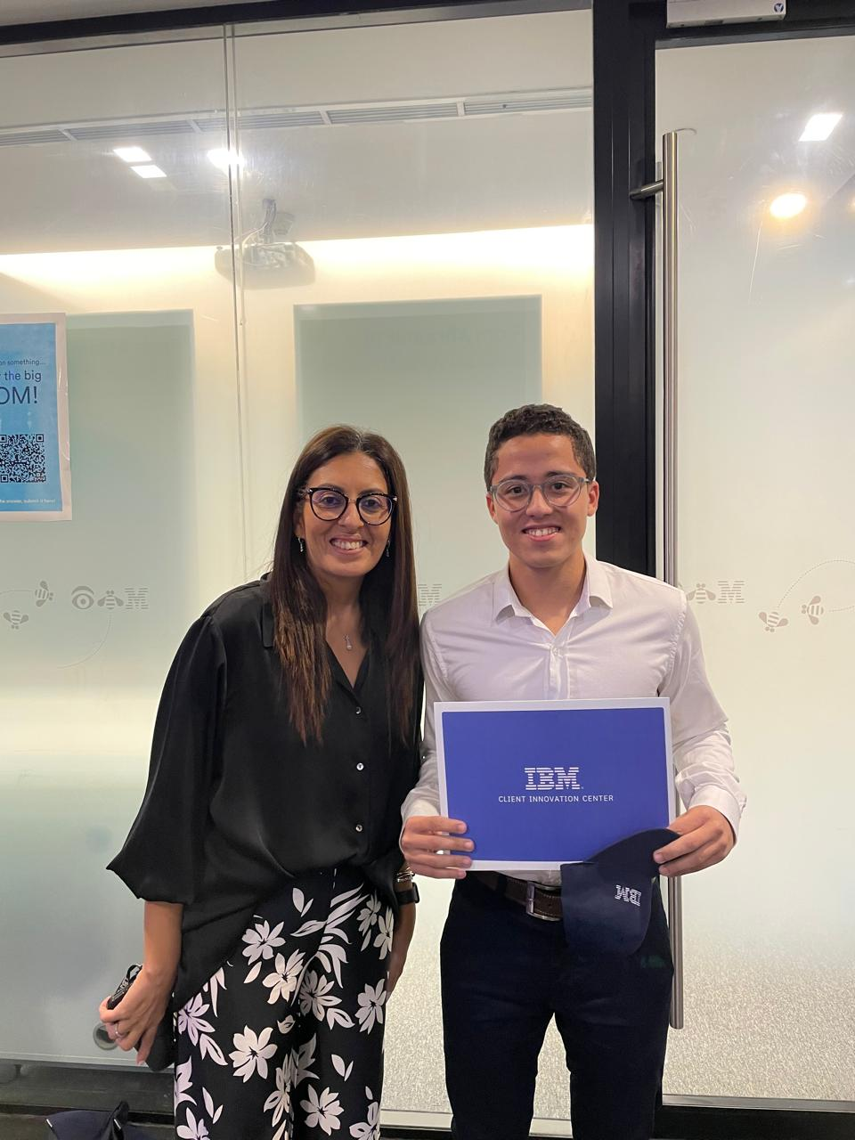 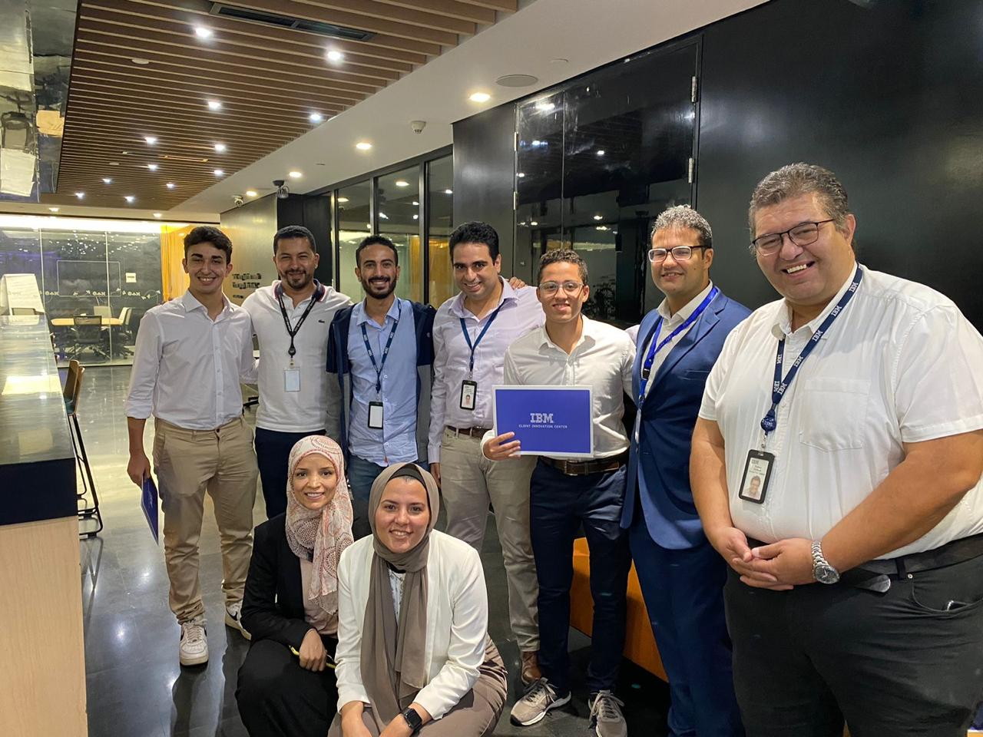

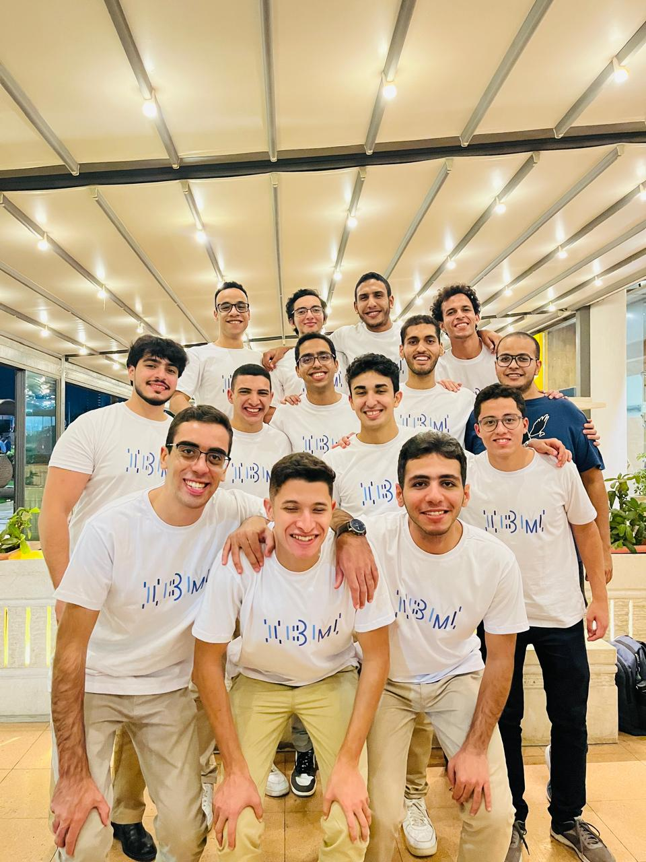 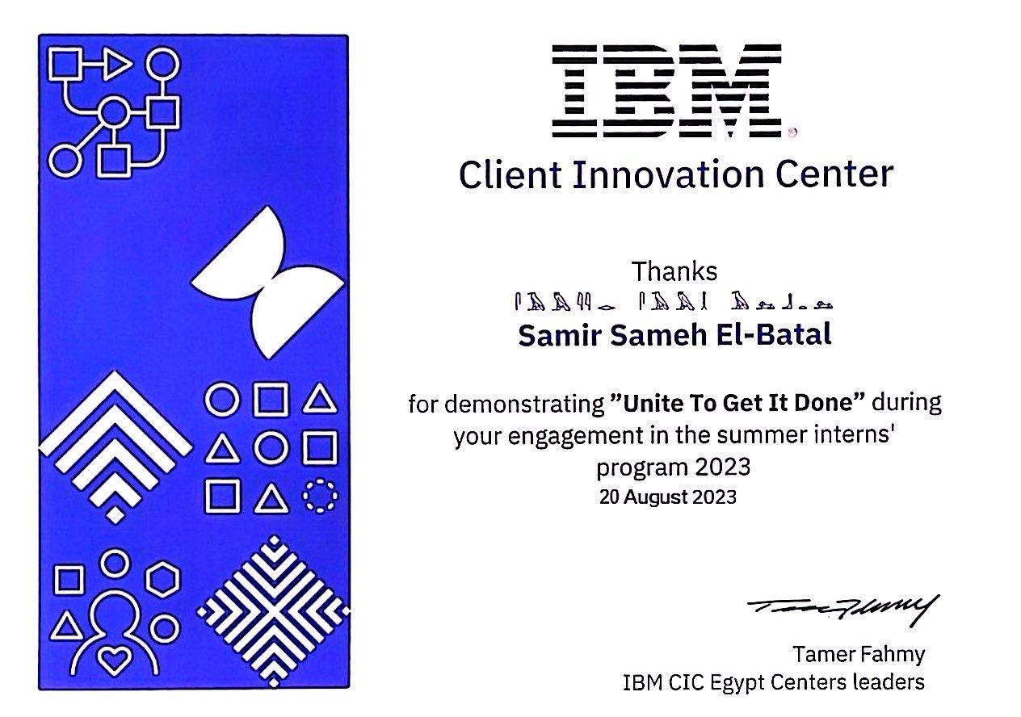

**Disclosure / Confidentiality Agreement**

This agreement is to acknowledge that the information provided by any company / organization during the internship is unique to this business and confidential.

Therefore, anyone reading this agreement agrees not to disclose any of the information provided during the internship without notifying & taking the employer’s / supervisor’s approval.